BALLYMAHON MUNICIPAL DISTRICT

Corporate Affairs,
Please note venue of meeting - Aras an Chontae,
St. Mary’s Parish Hall, Lanesboro. LONGFOIRT.

13th June 2017.

To: Each Member of the Ballymahon Municipal District.

A Chomhairleoir,

You are requested to attend the Annual Meeting of the Ballymahon Municipal District to be held in St. Mary’s Parish, Hall, Lanesboro, on Monday, 19th June 2017 at 4.00 p.m. to transact business, as set out on the Agenda hereunder.

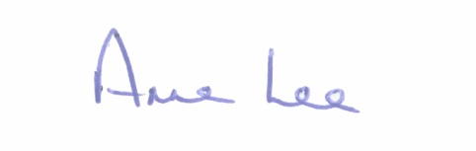
Mise le meas,

_______________
Anne Lee,
Meetings Administrator.

C L A R

1. Election of Cathaoirleach.

2. Election of Leas Cathaoirleach .

3. Fix date and time of Ballymahon Municipal District meetings.

